Tech Lithe Creations

30 January 2017

CIS 320-01

Iteration 1

**System Request** - this document will describe the business reasons for building the proposed system, and the value the system is expected to provide.

System Request - KHBPA Website Redesign

|  |  |
| --- | --- |
| Project Sponsor | Project Manager - Dr. Robert Barker |
| Business Need | Improve access to information  Improve member’s online experience  Receive donations online  Sell forms online  Push online news and stories  Publish media online  Link to social media  Process insurance claims online  Accept memberships online  Mitigate data disaster recovery  Poll members online |
| Business Requirements | Process credit card transactions  Broadcast newsletters/blog/newsfeed  Link to major social media sites  Product search (forms)  Membership database  Provide online access to information  Produce polling results  Data backup  Data continuity |
| Business Value | $672 savings in newsletter printing costs  $49,699 savings in newsletter mailing costs  13.2% increase in donations |
| Special Issues | End of semester deadline April |

**Narrative**

This document discusses the KY HBPA’s problem statement. It then describes Tech Lithe Creation’s business case. It then concludes with feasibility considerations.

Kentucky HBPA’s current website has several problems which we will address. Currently HBPA online abilities do not allow them to accept donations. Nonprofits like the Kentucky HBPA rely on donations to keep their operations going. Samantha Sharf with Forbes reports overall donations made online are up 13.2% from 2013. She goes on to say that 60% of millennials donate an average of $481 a year online. Currently, the HBPA cannot create their own news content to push feeds to members, they cannot create new members, and they cannot take payment for forms. Forms purchased by HBPA members are sold at cost by the organization. 90% of form purchases are done in person, and about 95% are paid for at time of pick up. The office executive assistant, Sara Toomey, then enters in a payment to a separate website and prints off the form. The Kentucky HBPA cannot provide benefits, produce licenses, poll members, process insurance claims, link to multiple social media sites, connect owners to buyers, receive user feedback, or allow users to submit photos. Beyond the current business problems the Kentucky HBPA has identified, two additional major items their current system lacks is data disaster recovery, and business continuity.

In order to fix the problems, TLC will partner with a credit card processing service such as Swipe or PayPal to give the Kentucky HBPA the ability to accept online payments. This will allow them to accept payment for forms, and donations through their website which will drive sales and donations. Driving a news feed on the homepage will allow HBPA to forego mailing newsletters. This will save greatly on costs, and increase reach. Sign Up forms will allow new members to join quick and easy on their own.

A simple online database would be essential in mitigating a complete loss of data. In their current state, if a disaster were to occur and all data lost, Kentucky HBPA would be a total loss. The ability to bounce back from this is impossible. The online database has an added benefit of creating business continuity, maintaining data integrity, and eliminating data redundancy.

Business Value - 6,000 members, 4 newsletters/year = 24,000 newsletters/year

1 ink cartridges (90,000 pages each, Xerox Workcentre 265, $399) - $106

48 reams of paper (500 sheets each, $11.79) = $566

48 boxes of envelopes (500 each, $15) = $720

24,000 stamps ($0.49) = $11,760

Technical Feasibility

The first element of technical feasibility is familiarity with the functional area. All six members of Tech Lithe Creations are familiar with websites and the components that make them up (tabs, search bars, etc.) The members of the KHBPA already have an existing website. This shows that they do have a familiarity with the application and adding extensions to this website will be much easier to understand for them, than creating a website for them, if they have never had a website.

Familiarity with technology is another element of technical feasibility. While the KHBPA has had a website before coming to us to improve it, they still do not have a strong familiarity with technology. This means there is a greater chance of problems occurring as our team tries to design a very user friendly website for them. This may also cause issues as we try to transfer all of KHBPA’s data to cloud storage and try to have all future data backed up to it.

Project size is also an element of technical feasibility. For the amount of time given, until the end of the semester, the project size seems to be of a manageable length. The website will not be integrated with a large amount of systems and neither will the cloud storage, therefore the complexity will not be increased to an unbearable size as only a small amount of systems will have to work together.

The new website will be compatible with the existing one as we plan on making extensions and modifications to the currently existing one. The cloud storage may prove to have some difficulty in compatibility as currently the data is stored in an external hard disk drive stored in a fire safe in Louisville, each employee’s personal computer, and on personal computers in their offices in Louisville and Lexington.

Our team assesses that this project is technically feasible. While difficulties have been noted to have the possibility of arising, improving the website and having KHBPA use cloud storage for data storage and management seems to be a very manageable task.

Economic Feasibility

|  |  |
| --- | --- |
|  | **2017** |
| Increased Donations | 792 |
| Reduction in Ink Cartridges Cost | 106 |
| Reduction in Reams of Paper Cost | 566 |
| Reduction in Boxes of Envelopes Cost | 720 |
| Reduction in Stamps Cost | 11,760 |
| Reduction in Website Maintenance | 300 |
| Reduction in Current Price of Domain | 2,988 |
| **TOTAL BENEFITS:** | 17,232 |
| **PV OF BENEFITS:** | **17,232** |
| **PV OF ALL BENEFITS:** | **17,232** |
|  |  |
| **TOTAL DEVELOPMENT COSTS:** | 0 |
|  |  |
| Website Domain Subscription | 120 |
| Microsoft Office Subscription | 80 |
| **TOTAL OPERATIONAL COSTS:** | **200** |
| **TOTAL COSTS:** | **200** |
| **PV OF COSTS:** | **200** |
| **PV OF ALL COSTS:** | **200** |
| **TOTAL PROJECT BENEFITS COSTS:** | **17,232** |
| **YEARLY NPV:** | **17,032** |
| **CUMULATIVE NPV:** | **17,032** |
| **RETURN ON INVESTMENT:** | **85.16** |
| **BREAK-EVEN POINT:** | **17,032** |

Organizational Feasibility

The website that will be created will meet the end goal of aligning with the goals of the KHBPA. The KHBPA is in need of a way to accept donations easily and a way to have customers pay for forms online. The website will be partnered with a credit card processing service such as Swipe or PayPal, which will give the KHBPA a way to accept online payments. The KHBPA also needs a way to push news content to its members, so members can stay informed on relevant issues that affect the KHBPA. The website will provide a solution to this problem by having the capability to push news content. The KHBPA does not have an easy way for members to be created currently, which lowers the popularity of the non-profit organization and therefore reduces funding. The website will allow memberships to be created easily, which will cause growth to the KHBPA and in turn, cause more prosperity for them. Currently, there is a lack of disaster recovery and business continuity. Once cloud storage, a part of this project, is implemented, this problem will be resolved.

The *champion* stakeholder is Dr. Robert Barker, as he is the project sponsor who created the system request. He has supported the project by providing time, resources, and workers (CIS 320 students). He is a person that can affect this new system, which causes him to be a stakeholder. Dr. Barker provides day-to-day support for the system. He has communicated the importance of the system to other organizational decision makers within the KHBPA and if he were to leave, the support could leave as well.

Management is also a stakeholder for this process. They convey to this rest of the organization the belief that this project will be a valuable asset that will enhance their non-profit organization and make necessary resources, such as a way for members to purchase forms easily, available. They will encourage employees to use the cloud storage and current and future members to use the website.

The third important set of stakeholders are the users, which are the employees, current members, and future members of the KHBPA. The final product of this project will ultimately help the users and directly affect how they interact with the KHBPA. This set of people is expected to use the final product of this project, making them a major stakeholder.

Final Feasibility Study

Overall, this project is manageable from a technical feasibility aspect, as our team is very capable of building a website and helping KHBPA upgrade to cloud storage. From an economic feasibility perspective, the project proves to be very affordable and will cause prosperity. This project will benefit employees, current members, and future members of the KHBPA. Therefore, from an organizational feasibility standpoint, this project is strategically aligned with the business and is therefore a project worth pursuing.

**Process models**

This document elaborates on the problem statement by displaying the current business process and exhibiting the envisioned business process, in the forms of an AS-IS Process Model and a TO-BE Process Model.

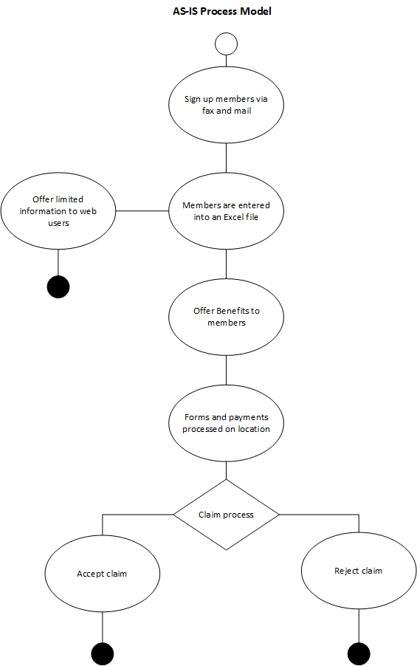

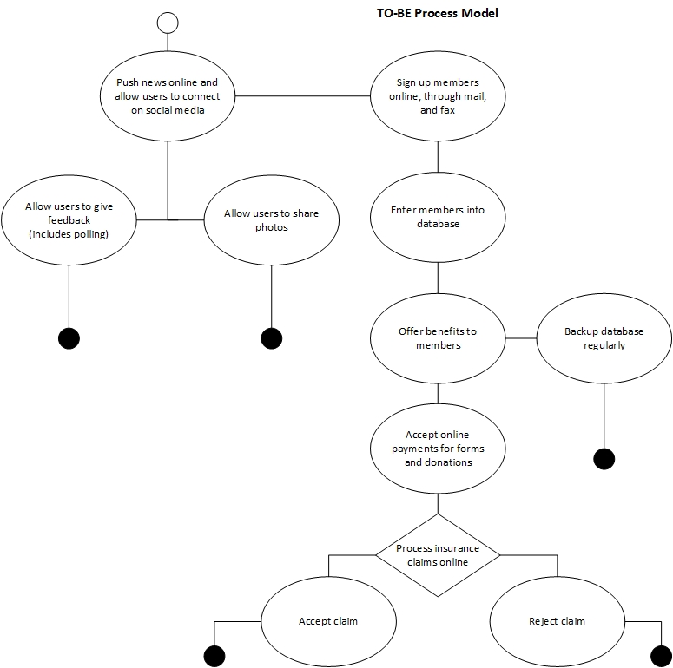

**Agile Stories**

This document contains four Agile stories for the client.

Agile breaks a problem or problems down into smaller parts that can be turned into user stories. User stories are a way for companies to approach certain issues from a different perspective. They start with a title, a viewpoint, a desire that one is seeking to accomplish, and an expected outcome of your actions. Once a user story is created, you must determine what the likely result will be. The format of a user story is as follows:

*Title: <a name for the user story>*

*As a <user or persona>*

*I want to <take this action>*

*So that <I get this benefit>*

**User Stories For KHBPA**

ID #: 1

Title: Newsletters and paper documents

As: a member of the site

I want: Quick and easy access to the documents KHBPA provides

So that: shipping or travel time is eliminated

When we reduce the amount of paper we use through newsletters, forms, and other various other documents, our printing costs go down. If the KHBPA were to publish its newsletters via its website, then they would be saving a significant amount of money.

ID #2

Title: Receiving Donations

As: a member and a donor

I want to: be able to donate to the KHBPA through the website

So that: The KHBPA can continue its mission

When we enable users to donate through our site, we capitalize on an opportunity to make money and we make it easier for them to do so. Currently, the KHBPA is missing out on a big opportunity to raise funds because of the lack of a donation feature. We expect KHBPA to increase the amount of donations received by roughly 13.2%.

ID #3

Title: Legislation

As: a member and an activist

I want to: effectively push for changes in legislation through the site

So that: the racing community as a whole is improved

When we bring these issues to light through our website, we bolster support for our cause and we broaden our audience .

ID #4

Title: Membership

As: a potential member of the KHBPA

I want to: Become a member through your website

So that: I avoid having to do it in person

When we simplify the membership process, we incentivize people to sign up because it’s easier to do.

**Team Charter**

This document describes Tech Lithe Creations’ team goals, information concerning team meetings, how team communications will be conducted, and how team decisions will be made.

Tech Lithe Creations, TLC, is our team for our CIS 320-01 course team project. Our team is made up of six students and a diverse age range from 19 to 29. We also are comprised of CIS – InfoSec and CIS - Web Development majors. This diversity will bring in different ideas and constructive discussions to improve the product for our client, KY HBPA. I believe I can speak for everyone in the group when I say that we want to improve our group skills as well as our client’s product. In the preceding text, our team’s goals, processes, and functionality are described to give insight into Tech Lithe Creations’ strategy to planning and designing an effective website for the KY HBPA.

TLC has set many goals that we think will help the KY HBPA in addition to developing our team skills and Agile/Scrum software development. TLC want to design and develop a meaningful and effective product that will fit the needs of our client’s audience as well as host their data and business processes/activities. Another goal is to communicate and work in a professional manner so that we can focus on our product for the KY HBPA. We also would like to develop valuable skills that will be rewarding in our business careers in the future. Our team knows how valuable Agile and Scrum software development is for team planning and collaboration in the Information Technology career area. Our primary focuses for this product are to produce a functional site with all the requirements fulfilled, develop valuable skills, and conduct ourselves professionally.

To expedite the process of schedule meetings and finding free time among the peers in TLC, we came up with an idea to use a mobile app called TimeTree. This mobile app is a calendar sharing app that allows us to be able to show our free times and be able to easily narrow down times to meet to work on our product. After finding common times for the six of us to meet, we arrange times to conduct meetings in person for discussions and brainstorming sessions or we can do this virtually over the mobile app GroupMe. This free app allows groups of people to message each other and can be accessed with an internet connection.

The team communicates ideas, technical materials, and decisions among its members with the GroupMe app, through Google Docs, and face-to-face in or out of class. To write out iterations, Tech Lithe Creations uses Google Docs which is aword processor of a free, browser-based software suite by Google within the Google Drive service. Google’s web-based word processor enables users to create and edit files online including collaboration with other users in real-time. We find that this is a very efficient way to work on our individual parts of iterations and to help fellow team members on their parts of the iterations. This type of virtual collaboration is exactly how IT areas in businesses conduct their day-to-day activities and is by far the most cost effective for both the business and the individual associate. TLC uses common email communication to connect with the client and course instructor, Dr. Robert Barker. Our email communication is beneficial for the client’s product details as well as Dr. Barker’s assignments.

Team decisions are made when a member proposes an idea that has multiple choices and tells the team, either through GroupMe or in person. Each member then says the decision they would prefer to be made. When a majority of at least four members shares the same opinion, then a consensus is built and that is the decision the group decides on and goes with. Another way to make team decisions is when we have a discussion about resolving a problem and multiple members think of a solution. We then build a consensus which is used as the deciding factor. To resolve conflicts, all members weigh in with their opinions and explain why they believe their opinion is accurate. Members say their opinions in a nonaggressive manner, so they do not further escalate a conflict. Through calm, rational conversation among the six of us, conflicts become resolved.

The team will maintain project documentation by saving all versions of the documents we create for our client, and making new versions when a decent amount of changes have been made. The team will also save iterations on Google Docs, this will help document the entire process of conducting this project as well as create a great environment for collaboration and sharing. Previous saved versions and iterations will serve as our project repository. The best reason for using Google Docs as our platform for sharing and collaborating is that we will always have a backup of our documents for this project. This is possible because Google Docs has the capability to automatically save the documents onto Google Drives. Backing up allows our team to not have to worry about losing our hard work and data but to instead focus on our content and resolutions for KY HBPA’s websites problems.

Tech Lithe Creations believes as a team will be able to help the KY HBPA efforts and ourselves will generate valuable experience throughout the process. By utilizing rational thought, communication, and our time and efforts towards this product, we are confident that the KY HBPA will have a website that they had always wanted. Tech Lithe Creations has a great team system in place and all members know what it takes to work in teams and come out successful. As long as we work together and share constructive criticism, TLC will proudly complete this product for our client and with all of their required features, processes, and solutions. We are very excited to being working with a great organization like the KY HBPA who provides countless services for our horse racing community here in Kentucky.